BPP Coursework Cover Sheet
Please use the table below as your cover sheet for the 1st page of the submission. The sheet should be before the cover/title page of your submission.
Programme | MSc Management
Module name | Personal Effectiveness
Schedule Term
Student Reference Number (SRN)
Report/Assignment Title | PERSONAL EFFECTIVENESS REPORT
Date of Submission
(Please attach the confirmation of any extension received)
Declaration of Original Work:

I hereby declare that I have read and understood BPP’s regulations on plagiarism and that this is my original work, researched, undertaken, completed and submitted in accordance with the requirements of BPP School of Business and Technology.
The word count, excluding contents table, bibliography and appendices, is 2504 words. Student Reference Number: Date:
By submitting this coursework you agree to all rules and regulations of BPP regarding assessments and awards for programmes. Please note, submission is your declaration you are fit to sit.
BPP University reserves the right to use all submitted work for educational purposes and may request that work be published for a wider audience.
BPP School of Business and Technology

PERSONAL EFFECTIVENESS REPORT

Abstract
The personal competence of the leadership is addressed in this report. The selected leader is LinkedIn business executive Jeff Weiner. The case study overview is addressed in this case. The positive as well as negative skills are addressed. Positive work culture leads the company successful. The case study of CEO Genome Project is addressed here. The limitations are summarized. “Behavioral leadership theory” is taken into consideration. This study has selected two online platforms that help learners to improve personal effectiveness. The advantages and challenges of both platforms have been described here. This study also described the learning styles and the strength and limitations of the learning styles.

Table of Contents
Introduction 5
Task 1: Case Study Review 5
1.1 Recognition of positive and negative skills/behaviours of a firm leader 5
1.2 Link to case studies 7
1.3 Investigation of advantages and limitations of skills/behaviours 7
1.4 Application of theory 8
Task 2: Evaluation of learning style 9
2.1 Explanation of main learning style 9
2.2 Challenges of online and remote working 11
Task 3: Description related to the online platforms 12
3.1 Advantages of LinkedIn online learning style 12
3.2 Advantages of Udemy online learning styles 13
3.3 Description of more appropriate online platforms 14
Conclusion 14
References 15
Appendix 19
Appendix 1: Growth is the primary concerning factor for CEOs 19

Introduction
“Personal effectiveness skills” are important for the major advancement in organisations. Thus, managers can effectively communicate with the employees, which boost the overall consumer buying perception. Thus, it is necessary need to perform with better ability and skills in the workplace. Basic problems in organizational processes may be resolved by the problem-solving skills and ideas of the executives. The creative process is also linked to these strategies. This paper analyses the "CEO Genome Project" case study. The selected leader is Jeff Weiner who serves as “LinkedIn's executive chairman” (linkedin.com, 2023).
The case focuses on evaluating several approaches to teaching leadership skills. Problems encountered by remote teams when using these platforms are also discussed. Applying "Honey and Mumford's learning styles" identifies the learning mode. This method successfully connects to the many "personal effectiveness" phases that play a vital role in the learning loops. This feature has also been included in the questionnaire format. The efficiency of the "online platforms" used in the research is also analysed. "LinkedIn Learning" and "Udemy" are used to conduct the research. In this instance, we compare the two platforms, which is an important step in the design process. In the last portion, the main points are recapped. This report has focused on some learning styles of leadership and the strength and limitation of leadership to improve the business and meet its objective of the business. This study has described a case study based on the demonstration of different business leaders. Leadership concepts and personal effectiveness for the improvement of the business have been described in this study thoroughly.

Task 1: Case Study Review

1.1 Recognition of positive and negative skills/behaviours of a firm leader
An introduction to the fundamental concepts of leadership and certain other essential ideas might result from this. The "global business leader" framework is used to acquire and measure the necessary skills and abilities.
Positive culture and plan in the workplace
The positive cultural behaviour of the employees leads them happier and more satisfied in the workplace. Moreover, workers feel more valued so that they can work effectively in the workplace (LeMieux, 2020). A firm's reputation may be enhanced by fostering a healthy corporate culture, and as a result, individuals that are more competent may turn to it while searching for new employment.
Managing the workforce
The likelihood that a professional would work much harder and have a good attitude may be increased if they love their organizational climate and have positive connections with their superiors and colleagues (Richter, 2019). Employees are less likely to think about switching jobs when they have the opportunity to learn and develop while working for one company.
Time Management skills
Effective time management enables company managers to complete more tasks in less time, which produces more time flexibility, improves concentration, boosts productivity, reduces stress, and increases time.
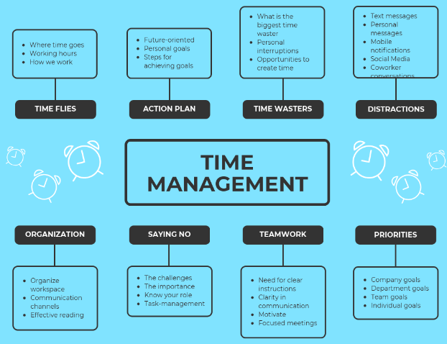

Figure 1.1: Time management skills of a leader
(Source: Adams and Blair, 2019)
Prior to joining LinkedIn, Jeff worked as an “Executive in Residence at Accel Partners” and “Greylock Partners”, where his main responsibilities included providing guidance to the top management of the company's current technological portfolio companies and collaborating intently with the collaborators to assess potential emerging investment tactics. However, organisational growth is the primary importance for the CEO.
However, Jeff Weiner's leadership talents are equally linked to the negative elements. The market share and quantity of LinkedIn have significantly decreased due to a lack of risk-taking skills. Sometimes, insufficient professionalism has resulted in flaws in LinkedIn products.

1.2 Link to case studies
As per the view of LeMieux (2020), the “CEO Genome Project” offers better statistics on the performing characteristics of the CEO in global projects. The project is encapsulated deliberately after a 10-year study. Thus, researchers become able to gain the necessary information and data to confirm the effectiveness of the gathered data. Philippidis (2019) explained that with accessibility to more than 17,000 evaluations of "C-suite executives, including 2,000 CEOs", the study examined data and details produced by "ghSmart", their management consultancy service. After defining what led to CEOs being selected in the first instance and what qualities enabled them to succeed in their roles, the report's authors evaluated the career records, financial outcomes, and social behaviours of executives.
The first result is linked to encouraging evidence of more participation. As a result, this may help them comprehend the stakeholder's activities and other abilities. Likewise, Greul and Widdig (2019) stated that Weiner has emphasized the need for "improved communication skills," which enable more interaction with peers and staff. The results of the investigation are also linked to the CEOs' increased self-efficacy and speed of acquisition. Weiner has also used "visionary techniques" and "innovative strategies" to concurrently monitor other online platforms. This may increase LinkedIn's acceptance on a worldwide scale.

1.3 Investigation of advantages and limitations of skills/behaviours
LinkedIn's workers' skills and capacities may grow as a result of the commercial prospects. Possess the abilities required to implement the necessary modifications to the way the business operates. As per the view of Aguado et al. (2019), a top team is based on the principle of developing relationships. Additionally, as a manager, agility and flexibility keep you at the forefront of technology. Every organization, like LinkedIn, must prioritize creativity in leadership. Imagination, the stage when wonderful things are formed, is where the technological project starts. LinkedIn administrators will remain to be motivated by the rising need for innovation and invention.

1.4 Application of theory
The “Behavioural leadership theory” is addressed in this case where leaders tend to alter the old business frameworks into new cultural formats (Oberer and Erkollar, 2018). This kind of leadership thought places less importance on a leader's skills, attributes, and instead emphasizes their activities and behaviour. A successful leader has several learned talents, according to this framework. Additionally to that, the idea takes into account that someone may gain the abilities necessary to develop into a successful manager.
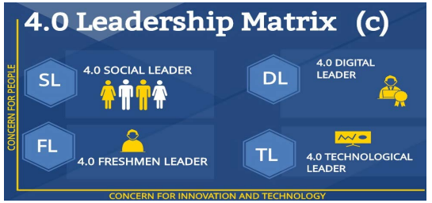

Figure 1.4: Leadership matrix of behavioural theory
(Source: Oberer and Erkollar, 2018)
It is monitoring or assessing a leader's actions or behaviours in response to a certain circumstance. According to this notion, developing into a leader is not a difficult task if the CEO is motivated to learn and use specific behaviours. In a similar way, Weiner has also enrolled “Behavioural leadership style” to align the business with a competitive direction (Purwanto, 2020). Moreover, it can come up with positive change within the organisation. Thus, Weiner promotes clear visions and goals towards fulfilling business objectives.

Task 2: Evaluation of learning style

2.1 Explanation of main learning style
The main learning style is “the theorist” which helps learners to grow self-effectiveness. This particular learning style helps the person to learn about the logical theory behind the action before deciding on a more fruitful plan. As per the viewpoint of Stewart (2021), theorists required some relevant models and concepts related to the actions so that they can get a clear idea about the entire action.
Theorists: Score 19  - Models  - Statistics  - Stories  - Quotes  - Background information  - Applying theories | Activist: Score 12  - Brainstorming  - Problem-solving  - Group discussion  - Puzzles  - Competitions  - Role-play
Pragmatism: Score 15  - Time to think about how to apply to learn in reality  - Case studies  - Problem-solving  - Discussion | Reflector: Score 14  - Paired discussions  - Self-analysis questionnaires  - Personality questionnaires  - Time out  - Observing activities  - Feedback from others  - Coaching  - Interviews
Table 1: Learning styles
(Source: Mint-hr.com, 2023)
Strength of theorist learning styles
The core strength of this learning style is that it helps to understand the entire action and possible problems step-by-step. It helps the person to define some fruitful strategies so that they can plan to get rid easily of problems in near future. As per the point of view of Magulod (2019), the LinkedIn online learning platform is very effective for learners to improve their personal effectiveness and their career as this platform has gained popularity in generating talented and skilled employees. Perfectionist is another word for the theorist as they like to prepare things into a scheme, which is rational (Mint-hr.com, 2023). This kind of leader always values rational and logical thinking that helps the leaders of theorists to minimize the challenges and threats. Theorist leaders have a habit to ask questions related to the circumstances. It helps them to get a full idea and create their own perspective based on the answers and opinions of others by questioning. The benefit of theorist learning styles is that it helps the business to minimize any kind of unpredictable risks and challenges.
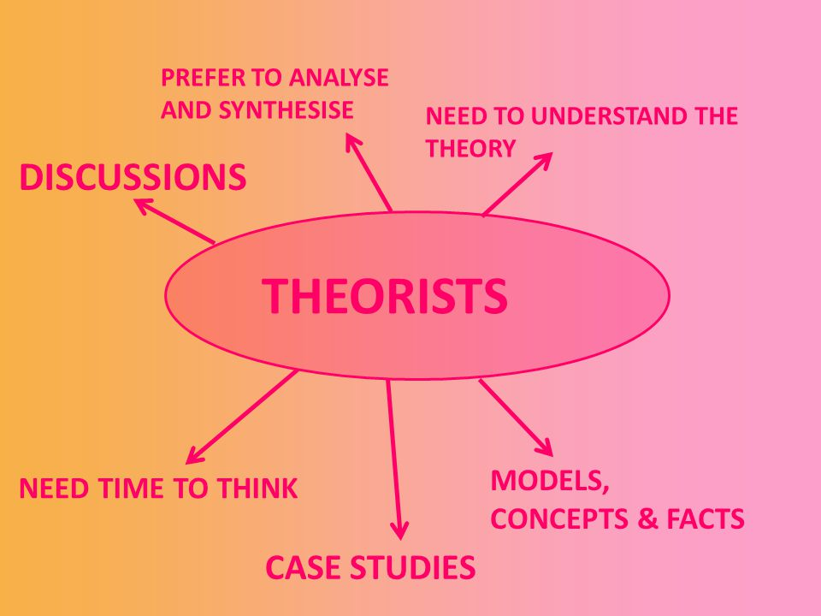

Figure 2.1: Theorist learning style
(Source: Magulod, 2019)
Limitations of theorist's learning styles
Theorist learning style though very beneficial for making any decision hence it has some limitations. In order to make any decisions, theorists need a wide range of information related to the model and concept which becomes difficult sometimes (Hasan and Khan 2020). Based on the point of view of theorists often believed in real cases and incidents in order to understand the theories behind the action and it often becomes impossible for them to find out the relevant incidents to verify the action as a result, they cannot get any ideas from their friends and relatives. This causes delays in making decisions and causes delays in taking any kind of action.

2.2 Challenges of online and remote working
Online learning platform is beneficial for learners to improve personal effectiveness. It has been observed that there are many challenges learners had faced while learning from online courses and the challenges have been explained in this study briefly. It is very expensive to learn online courses in remote working areas for many learners (Stokes et al. 2019). On the other hand, theorists can prepare a plan for the upcoming risks as they can assess the upcoming risk on a large scale but it is a very time taking process. The learners need to install some advanced and smart technologies and tools in order to get a course from the online platform and so they need to have a clear idea of operating those technologies.

Task 3: Description related to the online platforms
In the present era, online platforms for improving personal skills are very common for learners as learners do not need to present physically and can take courses virtually from any place. As suggested that Stewart (2021), career advancement becomes very easy by learning from online platforms as learners can learn from multiple experts virtually on the same topic. This study has selected two very popular online platforms that help learners to improve their personal skills and knowledge related to leadership. Here, two online platforms have been selected and two selected platforms for the learners are LinkedIn and Udemy.

3.1 Advantages of LinkedIn online learning style
LinkedIn has a job board for learners to get effective opportunities to improve their personal growth related to leadership. According to Wang et al. (2021), the learning style of this platform provides videos related to the topic that helps the learners to understand that particular topic easily. The learning path of this platform is full of valuable and informative courses that help the learner gather a huge amount of knowledge and can improve personal effectiveness.
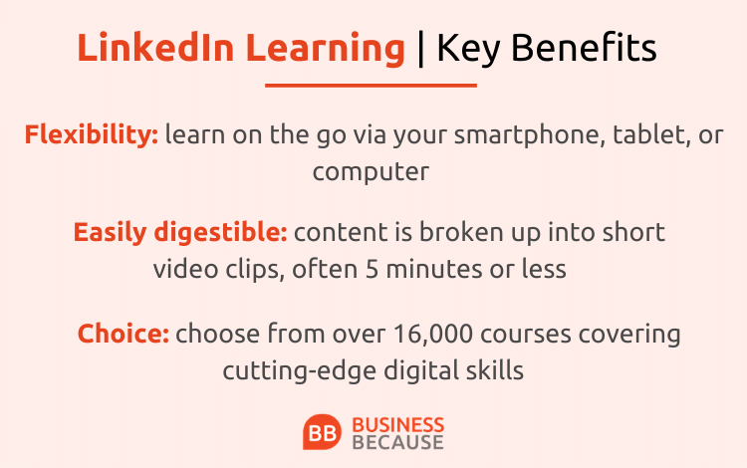

Figure 3.1: Advantage of LinkedIn online platform
(Source: Wang et al. 2021)
Challenges of LinkedIn online learning style
The major disadvantage a learner can face while creating an account on LinkedIn is that this online platform still provides some courses and content that is outdated. Certificates provided by LinkedIn are not so much acceptable in colleges and universities. Topics related to self-growth are very limited and the courses are so “overproduced” that include a heavy tone of corporate sectors [Refer to appendix 1].

3.2 Advantages of Udemy online learning styles
The major advantage a learner can get by creating an account on Udemy is that the learning fee is very affordable. It has been noticed that many eager learners cannot learn online because of the huge fees and those learners will get benefits related to the improvement of personal effectiveness. As per the suggestion of Jain and Gupta (2022), the range of courses related to self-development is wide; almost 200000 courses are available so that learners can select one of the courses according to their requirements (Udemy, 2023). It has been observed that leaders play a crucial role in the growth of the business. Thus, professionals also get many opportunities to improve self-effectiveness related to leadership.


Figure 3.2: Advantage of Udemy online platform
(Source: Jain and Gupta 2022)
Challenges of Udemy online learning styles
The disadvantage of using this online platform is that this platform is not considered an accredited institution so the certificate provided by Udemy is not acceptable in any kind of educational institution. Most companies do not believe in the course certificate provided by Udemy online platforms only while appointing some employees.

3.3 Description of more appropriate online platforms
Theorist learning style can be beneficial for learners to improve their personal effectiveness as this learning style helps to understand the background theory of the action and helps to plan according to the understanding. On this online platform, a well-known and very effective course is available related to increasing confidence. As opined by Pei and Wu (2019), as a leader, it is vital to building self-confidence so that leaders can step up for any new strategy and plan. More than that, self-confidence helps to define whether the person is able to develop the plan as a leader for the company after evaluating the theory behind the action. Theorists required models and thorough concepts related to the action and the course done on Linkedin helps to match up with the theory and the action.

Conclusion
The purpose of the study is to understand the necessity of improvement of personal effectiveness and the advantage of online platforms to improve. This study sheds light on personal effectiveness and the process of the enhancement of personal skills. In order to emphasize this study, the famous business leader Jeff Weiner has been chosen. While continuing this study, it has been identified that some online platforms are available for learners to improve their personal skills. Furthermore, this study has described which platform is best and most effective for learners to improve their personal skills. It has been observed that the theorist's learning style is more suitable for learners as it helps to evaluate the theory behind the action. The CEO of Genome has positive work culture and a great sense of time management, which helps him to become a successful leader. This online platform helps the learners to identify their strong areas so that they can work for the improvement of that particular area. The strength of the learning styles is that it helps to minimize unpredictable risk and the limitation of the learning styles is that it requires a wide range of knowledge. LinkedIn can be considered the most suitable online platform that helps to gain knowledge about theorists' learning styles.

References
Task 1
Journals
Adams, R.V. and Blair, E., 2019. Impact of time management behaviors on undergraduate engineering students’ performance. Sage Open, 9(1), p.2158244018824506. Available through: https://journals.sagepub.com/doi/pdf/10.1177/2158244018824506 [Accessed 17 January 2023]
Aguado, D., Andrés, J.C., García Izquierdo, A.L. and Rodríguez, J., 2019. LinkedIn" Big Four": Job performance validation in the ICT sector. Journal Of Work And Organizational Psychology-Revista de Psicología del Trabajo y de las Organizaciones, 35. Available through: https://digibuo.uniovi.es/dspace/bitstream/handle/10651/53177/LinkedIn.pdf?sequence=1 [Accessed 17 January 2023]
Greul, N. and Widdig, T., 2019. Deal Logic LinkedIn/Microsoft. Available through: https://opus4.kobv.de/opus4-whu/files/757/Deal_Logic_Microsoft_LinkedIn.pdf [Accessed 17 January 2023]
LeMieux, J., 2020. The Human Genome Project in 2020 Hindsight: Two decades after the working draft of the human genome was completed, it is clearer than ever that analysis of the text is just getting started. Genetic Engineering & Biotechnology News, 40(6), pp.16-18. Available through: https://www.liebertpub.com/doi/full/10.1089/gen.40.06.07 [Accessed 17 January 2023]
Oberer, B. and Erkollar, A., 2018. Leadership 4.0: Digital leaders in the age of industry 4.0. International journal of organizational leadership. Available through: https://ijol.cikd.ca/article_60332_a88c6cbb2e0af05dcbe51cf06845b231.pdf [Accessed 17 January 2023]
Philippidis, A., 2019. Amplification Litigation: Human Genome Project Leader Among Shareholders in Legal Wrangle Over Milestones for PCR Alternative. Available through: https://www.liebertpub.com/doi/full/10.1089/clinomi.06.02.08 [Accessed 17 January 2023]
Purwanto, A., 2020. The impacts of leadership and culture on work performance in service company and innovative work behavior as mediating effects. Journal of Reseacrh in Business, Economics, and Education. Available through: https://papers.ssrn.com/sol3/papers.cfm?abstract_id=3985680 [Accessed 17 January 2023]
Richter, F., 2019, Growth Remains a Top Priority for CEOs.[online] Available at: https://www.statista.com/chart/18223/top-strategic-priorities-for-businesses-in-2019-and-2020/ [Accessed 9 January 2023]
Task 2
Magulod Jr, G.C., 2019. Learning styles, study habits and academic performance of Filipino University students in applied science courses: Implications for instruction. JOTSE: Journal of Technology and Science Education, 9(2), pp.184-198. Available at: https://upcommons.upc.edu/bitstream/handle/2117/134350/504-3078-1-PB.pdf?sequence=1 [Accessed 9 January 2023]
Stewart, M., 2021. Understanding learning:: Theories and critique. In University teaching in focus (pp. 3-28). Routledge. Available at: https://www.researchgate.net/profile/Martyn-Stewart/publication/258441417_STEWART_M_2012_%27Understanding_learning_theories_and_critique%27_in_LHunt_and_D_Chalmers_eds_University_teaching_in_focus_a_learning-centred_approach_London_Routledge/links/5696676108aea2d7437467be/STEWART-M-2012-Understanding-learning-theories-and-critique-in-LHunt-and-D-Chalmers-eds-University-teaching-in-focus-a-learning-centred-approach-London-Routledge.pdf [Accessed 9 January 2023]
Stewart, M., 2021. Understanding learning:: Theories and critique. In University teaching in focus (pp. 3-28). Routledge. Available at: https://www.researchgate.net/profile/Martyn-Stewart/publication/258441417_STEWART_M_2012_%27Understanding_learning_theories_and_critique%27_in_LHunt_and_D_Chalmers_eds_University_teaching_in_focus_a_learning-centred_approach_London_Routledge/links/5696676108aea2d7437467be/STEWART-M-2012-Understanding-learning-theories-and-critique-in-LHunt-and-D-Chalmers-eds-University-teaching-in-focus-a-learning-centred-approach-London-Routledge.pdf [Accessed 9 January 2023]
Wang, B., Liu, Y., Qian, J. and Parker, S.K., 2021. Achieving effective remote working during the COVID‐19 pandemic: A work design perspective. Applied psychology, 70(1), pp.16-59. Available at: https://iaap-journals.onlinelibrary.wiley.com/doi/am-pdf/10.1111/apps.12290
[Accessed 9 January 2023]
Task 3
Hasan, N. and Khan, N.H., 2020. Online teaching-learning during covid-19 pandemic: students’ perspective. The Online Journal of Distance Education and e-Learning, 8(4), pp.202-213. Available at: https://www.researchgate.net/profile/Naziya-Hasan/publication/344932812_ONLINE_TEACHING-LEARNING_DURING_COVID-19_PANDEMIC_STUDENTS'_PERSPECTIVE/links/5f9993f9458515b7cfa45173/ONLINE-TEACHING-LEARNING-DURING-COVID-19-PANDEMIC-STUDENTS-PERSPECTIVE.pdf[Accessed 9 January 2023]
Jain, M.K. and Gupta, S., 2022. A Pragmatic Analysis of Mobile and MOOCs Based Learning Methods. Journal of Engineering Education Transformations, 35(4). Available at: https://ijaem.net/issue_dcp/Benefits%20of%20Online%20Language%20Learning:%20Study%20on%20IGNOU%20rOnline%20Arabic%20Language%20Learners.pdf [Accessed 9 January 2023]
Pei, L. and Wu, H., 2019. Does online learning work better than offline learning in undergraduate medical education? A systematic review and meta-analysis. Medical education online, 24(1), p.1666538. Available at: https://jamanetwork.com/journals/jamanetworkopen/articlepdf/2758475/desai_2020_oi_190713.pdf [Accessed 9 January 2023]
Stokes, Y., Vandyk, A., Squires, J., Jacob, J. D. and Gifford, W. 2019. Using Facebook and LinkedIn to recruit nurses for an online survey. Western journal of nursing research, 41(1), 96-110. Available at: https://journals.sagepub.com/doi/pdf/10.1177/0193945917740706 [Accessed 9 January 2023]
Websites
linkedin.com, 2023, Jeff Weiner Available at: https://www.linkedin.com/in/jeffweiner08 [Accessed 9 January 2023]
Mint-hr.com, 2023, Learning style, Available at: https://www.mint-hr.com/mumford.html [Accessed 9 January 2023]
Udemy.com, 2023, Online courses, Available at: https://www.udemy.com/ [Accessed 9 January 2023]

Appendix

Appendix 1: Growth is the primary concerning factor for CEOs
